Hypertext Transfer Protocol (HTTP) Hypertext Transfer Protocol (HTTP) is a set of standards allowing internet users to exchange website information.

HTTP/1.1 vs. HTTP/2 Protocol

HTTP/2 improved on HTTP/1.1 in a number of ways that allowed for speedier content delivery and improved user experience, including:

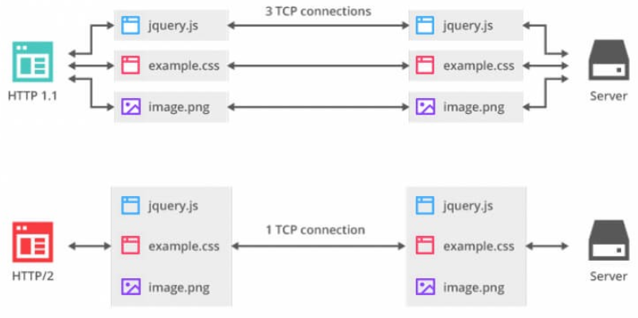

Binary protocols – Binary protocols consume less bandwidth, are more efficiently parsed and are less error-prone than the textual protocols used by HTTP/1.1. Additionally, they can better handle elements such as whitespace, capitalization and line endings.

Multiplexing – HTTP/2 is multiplexed, i.e., it can initiate multiple requests in parallel over a single TCP connection. As a result, web pages containing several elements are delivered over one TCP connection. These capabilities solve the head-of-line blocking problem in HTTP/1.1, in which a packet at the front of the line blocks others from being transmitted.

Header compression – HTTP/2 uses header compression to reduce the overhead caused by TCP’s slow-start mechanism.

Server push – HTTP/2 servers push likely-to-be-used resources into a browser’s cache, even before they’re requested. This allows browsers to display content without additional request cycles.

Increased security – Web browsers only support HTTP/2 via encrypted connections, increasing user and application security.

